2ND CAT 3RD TERM

JSS 2

1. A basket contains 40mangoes, out of which 22 are good. Find the percentage of the mangoes that are bad A. 18 B. 22 C. 24 D. 45
2. What is the sum of the interior angle of an octagon A.680⁰ B. 720⁰ C. 1080⁰ D. 1200⁰
3. Which of these angle is complementary to 70⁰ A. 20⁰ B. 30⁰ C. 90⁰ D. 110⁰
4. The sum of supplementary angles is A.90⁰ B. 180⁰ C. 240⁰ D. 360⁰
5. Find the exterior angle of a regular decagon A. 30⁰ B. 36⁰ C. 40⁰ D. 45⁰
6. Find the sum of 3x, (1 – 6x), 4x and x A. 1 – 2x B. 1 – 3x C. 2x + 1 D. 2x – 1
7. A number which is one more than n is A. 1 – n B. n + 1 C. n -1 D. 2n
8. Find the value of - 5 - (- 20) A. – 30 B. -25 C. -15 D. 15
9. Express 33% as a decimal number A. 0.30 B. 0.31 C. 0.32 D. 0.33
10. Approximate 13075 to the nearest thousand A. 13000 B. 13015 C. 13045 D. 13065

THEORY

1. 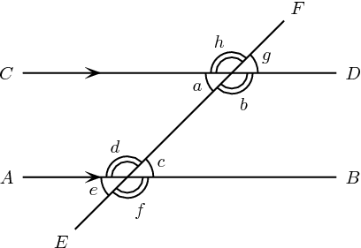

Given that h = 64⁰, find the rest of the marked angles

1. In a bag containing 6 green balls, 5 white balls and 4 red balls, a ball is picked at random, find the probability of picking (i) a white ball (ii) a green ball (iii) white or green ball